Bo Cui August, 1, 2011
Weekly report
Last week task:
- Neural cell activity diagram
- Moving obstacle cases
- Angular algorithm cases
- Virtual obstacle cases
This week task:
Search CNN maps and do more cases with angle algorithm and virtual obstacle/robot method.
Case 1:
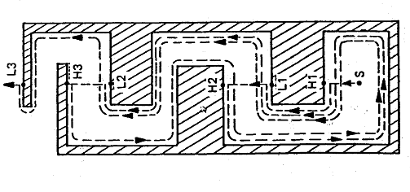
Fig.1 case 1 original map
This map is from the paper:
V. J. Lumelski. Dynamic Path Planning for a Mobile Automaton with Limited Information on the Environment. 1986, IEEE Transactions on automatic control, vol. AC-31, No. 11.
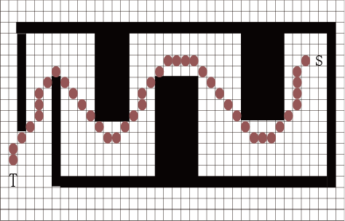
Fig.2 case 1 with CNN model
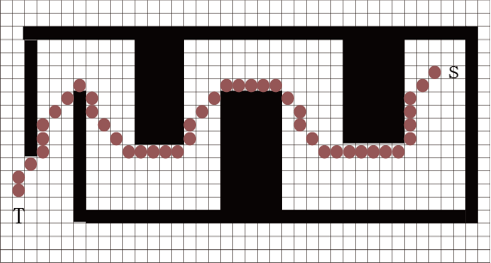
Fig.3 case 1 with angle algorithm
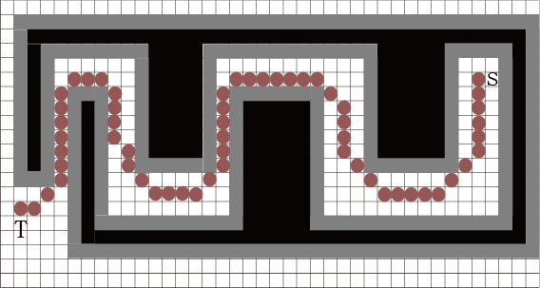
Fig.4 case 1 with virtual obstacle
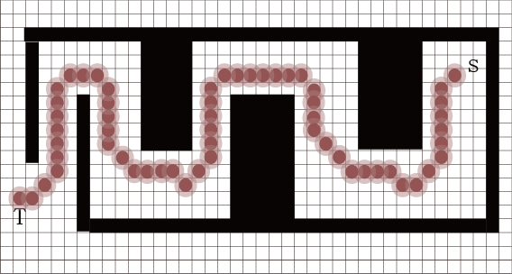
Fig.5 case 1 with virtual robot
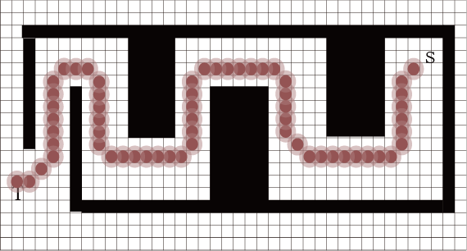
Fig.6 case 1 with both angle algorithm and virtual robot
Table 1 case 1 length
type | Path length
Original map | No length
CNN model | 52.60
CNN model with angle algorithm | 51.28
CNN model with virtual obstacle | 64.46
CNN model with virtual robot | 64.46
CNN model with both angle algorithm and virtual robot | 63.97

Case 2
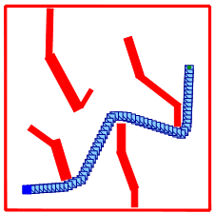
Fig.7 case 2 original map
This map is from the paper:
James J. Kuffner, Jr. RRT-Connect: An Efficient Approach to Single-Query Path Planning. 2000.
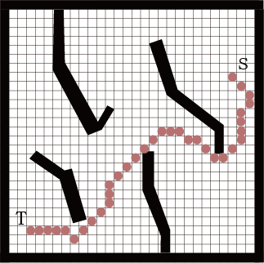
Fig.8 case 2 with CNN model
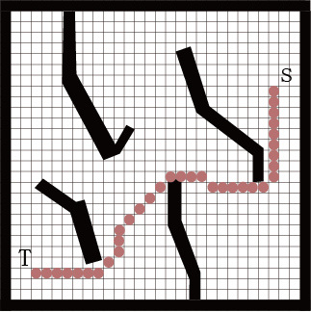
Fig.9 case 2 with angle algorithm
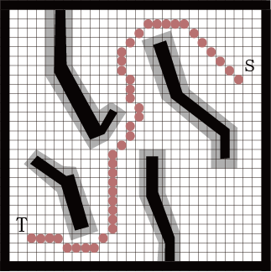
Fig.10 case 2 with virtual obstacle
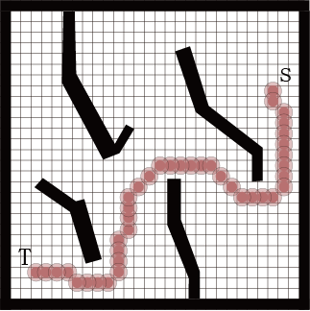
Fig.11 case 2 with virtual robot
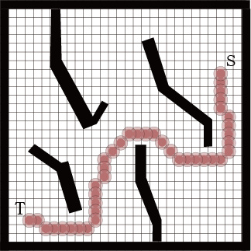
Fig.12 case 2 with both angle algorithm and virtual robot
Table 2 case 2 length
type | Path length
Original map | 37.45
CNN model | 40.87
CNN model with angle algorithm | 36.73
CNN model with virtual obstacle | 48.04
CNN model with virtual robot | 43.56
CNN model with both angle algorithm and virtual robot | 43.56

Case 3
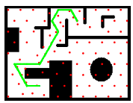
Fig.13 case 3 original map
This map is from the paper:
Amir Reza Saffari Azar. Self-Organizing Spiking Neural Networks for Environment Representation of Mobile Robot with Path Planning.
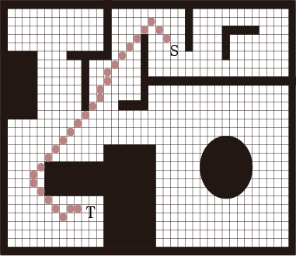
Fig.14 case 3 with CNN model
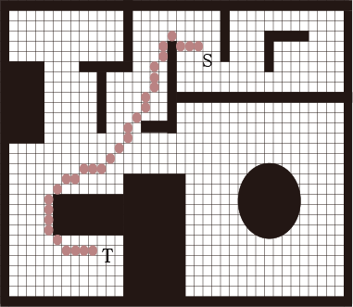
Fig.15 case 3 with angle algorithm
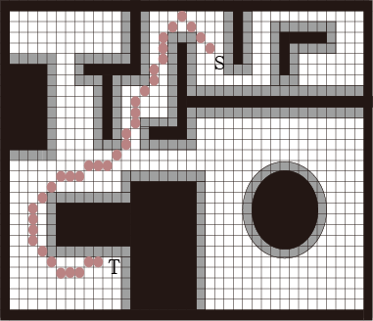
Fig.16 case 3 with virtual obstacle
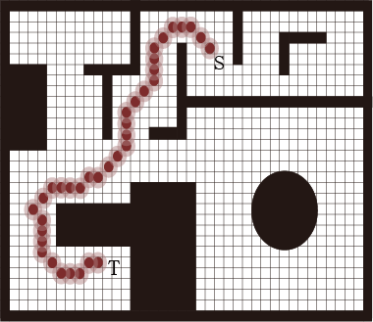
Fig.17 case 3 with virtual robot
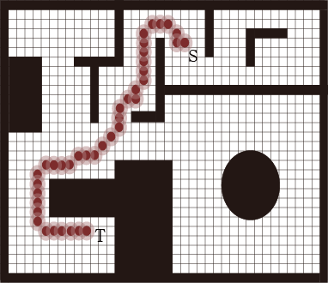
Fig.18 case 3 with both angle algorithm and virtual robot
Table 3 case 3 length
type | Path length
Original map | 46.20
CNN model | 36.53
CNN model with angle algorithm | 35.80
CNN model with virtual obstacle | 42.87
CNN model with virtual robot | 41.04
CNN model with both angle algorithm and virtual robot | 42.14

